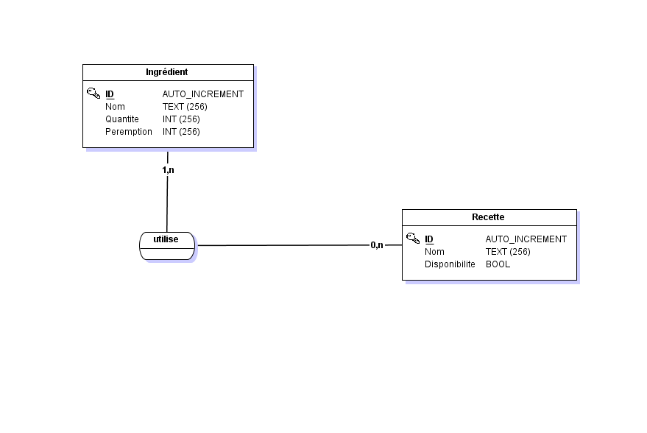 MCD

#------------------------------------------------------------

# Script MySQL.

#------------------------------------------------------------

#------------------------------------------------------------

# Table: Ingrédient

#------------------------------------------------------------

CREATE TABLE Ingredient(

ID Int Auto_increment NOT NULL ,

Nom Text NOT NULL ,

Quantite Int NOT NULL ,

Peremption Int NOT NULL

,CONSTRAINT Ingredient_PK PRIMARY KEY (ID)

)ENGINE=InnoDB;

#------------------------------------------------------------

# Table: Recette

#------------------------------------------------------------

CREATE TABLE Recette(

ID Int Auto_increment NOT NULL ,

Nom Text NOT NULL ,

Disponibilite Bool NOT NULL

,CONSTRAINT Recette_PK PRIMARY KEY (ID)

)ENGINE=InnoDB;

#------------------------------------------------------------

# Table: utilise

#------------------------------------------------------------

CREATE TABLE utilise(

ID Int NOT NULL ,

ID_Ingredient Int NOT NULL

,CONSTRAINT utilise_PK PRIMARY KEY (ID,ID_Ingredient)

,CONSTRAINT utilise_Recette_FK FOREIGN KEY (ID) REFERENCES Recette(ID)

,CONSTRAINT utilise_Ingredient0_FK FOREIGN KEY (ID_Ingredient) REFERENCES Ingredient(ID)

)ENGINE=InnoDB;